• Jahid Chowdhury Choton8/5 3:56 PM
sorry was away for a moment
• William Hsu8/5 3:59 PMWilliam Hsu8/5/2025 3:53 PM📷
Social Posts
- Raw posts - posts saved from platforms as files (currently on Google Cloud) by DC, used to make indexed posts; original source data for IE
- Indexed posts - posts that have undergone preliminary video-to-text (v2t) tasks including ASR & OCR to produce PG database entries aka "JSON tuples" aka "4-5 text blobs"; source data for IE
- Annotated posts - posts that are output by IE; currently to be committed to (a different table of) the PG database; specified inference output for IE
- Specify multimodal analysis VLMs
- Use the Data Collection API
- This is our shared target data model
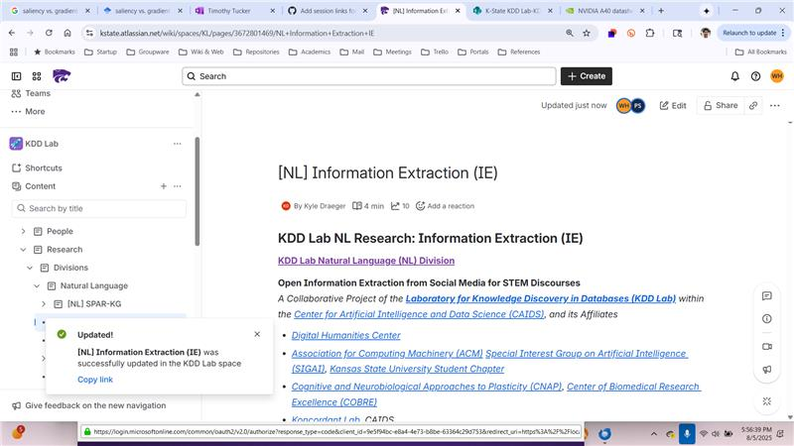
• EditedWilliam Hsu8/5/2025 3:59 PMSocial Posts Raw posts - posts saved from platforms as files (currently on Google Cloud) by DC, used to make indexed posts; original source data for IEIndexed posts - posts that have undergone preliminary video-to-text (v2t) tasks including ASR & OCR to produce PG database entries aka "JSON tupl…
Bill to refine: https://chatgpt.com/share/687bc5a6-b4e0-8002-87a3-0fb430f1b4e9
Help me choose a scientific domain of interest for developing a research test bed on open information extraction from social media. The domain can be any STEM-related topic so long as there is already an existing dataset of social posts about the topic and one of the social media platforms is a video sharing platform such as TikTok. In descending order of priority, the preferred platforms are: TikTok, YouTube, Spotify, Apple Podcasts, BlueSky, Reddit, Mastodon, Instagram, Threads, Facebook, and X (formerly Twitter). Criteria other than the number of available posts are an API that has a free tier (even if the number of posts per day is limited by the terms of service, and a research license must be applied for).

ChatGPT - OIE Research Test Bed
Shared via ChatGPT
chatgpt.com
• William Hsu8/5/2025 3:33 PM📷
Current rankings:
- Climate Change & Environmental Science
- Mental Health
- 3-way tie
  - Consumer Tech / AI Tools
  - Space & Astronomy
  - Neuroscience / Brain Hacks
• William Hsu8/5/2025 4:02 PMCurrent rankings: Climate Change & Environmental ScienceMental Health3-way tie Consumer Tech / AI ToolsSpace & AstronomyNeuroscience / Brain Hacks
Seeds for climate Open IE task
- TikTok: Multiple studies and datasets exist for climate misinformation and climate activism (see TikTok data on climate denialism or youth climate protests).
- YouTube: Extensive datasets, e.g. ClimateTube, plus established crawling practices for video descriptions, comments, and transcripts.
- Reddit: Subreddits like r/climate, r/environment, r/climateskeptics, r/solar, r/sustainability have active communities.
- Twitter/X & Mastodon: Climate tweet datasets exist, including those annotated for stance, misinformation, sentiment, etc.
- Podcast Platforms: Climate and sustainability are increasingly featured on Spotify and Apple Podcasts. Searchable via open podcast indices (e.g., iTunes RSS, ListenNotes API).
• William Hsu8/5/2025 4:03 PMSeeds for climate Open IE task TikTok: Multiple studies and datasets exist for climate misinformation and climate activism (see TikTok data on climate denialism or youth climate protests).YouTube: Extensive datasets, e.g. ClimateTube, plus established crawling practices for video descriptions, c…
Climate discourse on social media involves:
- Misinformation detection.
- Multimodal reasoning (text, video, audio).
- Temporal/event-based extraction (e.g. COP events, wildfires, climate protests).
- Public opinion mining, policy support, and community activism analysis.
• William Hsu8/5/2025 4:03 PMClimate discourse on social media involves: Misinformation detection.Multimodal reasoning (text, video, audio).Temporal/event-based extraction (e.g. COP events, wildfires, climate protests).Public opinion mining, policy support, and community activism analysis.
Patrick: LangChain inference - any others?
LangChain’s suite of products supports developers along each step of their development journey.
www.langchain.com
• JIA Shuyue (Guest)8/5 4:06 PMEdited
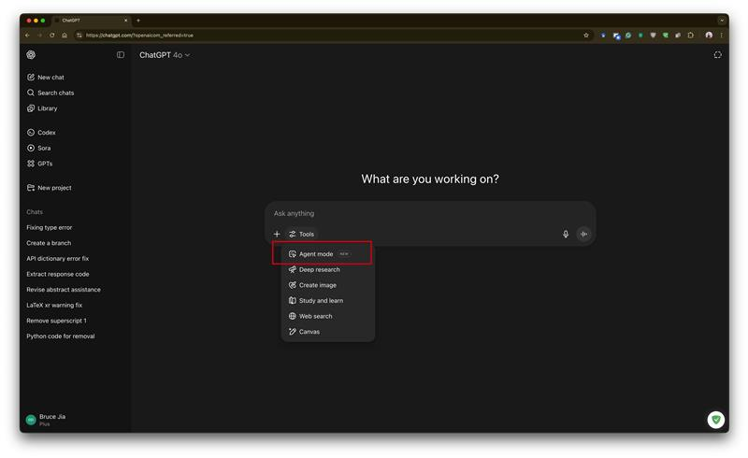
The Agent mode of ChatGPT
1 Like reaction with medium light skin tone.
• William Hsu8/5 4:06 PMEditedWilliam Hsu8/5/2025 4:05 PMPatrick: LangChain inference - any others?
Patrick:
- Flowise
- OpenAI agentic SDK - https://openai.github.io/openai-agents-python/
- n8n
Build AI Agents, Visually. Contribute to FlowiseAI/Flowise development by creating an account on GitHub.
github.com
• William Hsu8/5/2025 4:06 PMPatrick: FlowwiseOpenAI agentic SDK - https://openai.github.io/openai-agents-python/
https://flowiseai.com
Flowise - Build AI Agents, Visually
Open source generative AI development platform for building AI agents, LLM orchestration, and more
flowiseai.com
• JIA Shuyue (Guest)8/5 4:09 PM
For the AI agent with tool using
---
I am using this model right now:
https://huggingface.co/Qwen/Qwen3-30B-A3B-Thinking-2507

Previously, I used the Qwen2.5:
https://huggingface.co/Qwen/Qwen2.5-72B-Instruct
1 Like reaction with medium light skin tone.
• William Hsu8/5 4:09 PMWilliam Hsu8/5/2025 4:06 PMPatrick: FlowiseOpenAI agentic SDK - https://openai.github.io/openai-agents-python/n8n
Patrick's recommendation: https://n8n.io
n8n.io - AI workflow automation tool
n8n is a free and source-available workflow automation tool
n8n.io
• William Hsu8/5/2025 4:09 PMPatrick's recommendation: https://n8n.io
Bruce's recommendation: https://github.com/QwenLM/Qwen
GitHub - QwenLM/Qwen: The official repo of Qwen (通义千问) chat & pretrained large language model proposed by Alibaba Cloud.
The official repo of Qwen (通义千问) chat & pretrained large language model proposed by Alibaba Cloud. - QwenLM/Qwen
github.com
• William Hsu8/5/2025 4:10 PMBruce's recommendation: https://github.com/QwenLM/Qwen
https://github.com/QwenLM/Qwen
GitHub - QwenLM/Qwen: The official repo of Qwen (通义千问) chat & pretrained large language model proposed by Alibaba Cloud.
The official repo of Qwen (通义千问) chat & pretrained large language model proposed by Alibaba Cloud. - QwenLM/Qwen
github.com
• EditedWilliam Hsu8/5/2025 4:10 PMhttps://github.com/QwenLM/Qwen
https://pypi.org/project/qwen-agent/ (Bruce is using VLLM to serve)
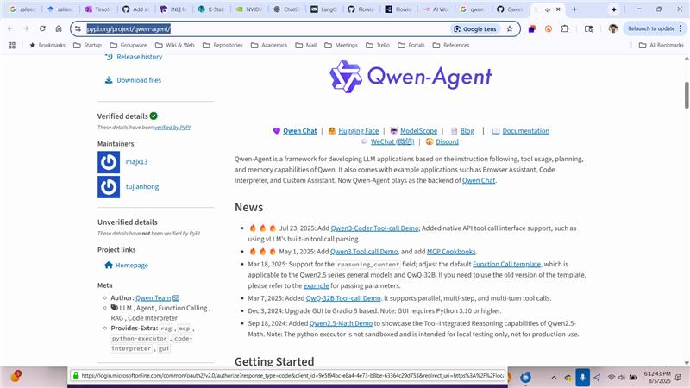
qwen-agent · PyPI
Qwen-Agent: Enhancing LLMs with Agent Workflows, RAG, Function Calling, and Code Interpreter.
pypi.org
• William Hsu8/5/2025 4:12 PMhttps://pypi.org/project/qwen-agent/ (Bruce is using VLLM to serve) 📷
Multistage gradient-directed data augmentation
- well-defined for CV tasks (even VLM)
- not as well-defined for reasoning tasks & LTR
• William Hsu8/5/2025 4:15 PMMultistage gradient-directed data augmentation well-defined for CV tasks (even VLM)not as well-defined for reasoning tasks & LTR
well-defined for CV tasks (even VLM) -> lookahead policy search

Original: https://aaai.org/papers/ws02-15-004-real-time-lookahead-control-policies/
Real-Time Lookahead Control Policies - AAAI
A post from anthonyShift on AAAI provided by: https://aaai.org
aaai.org
• William Hsu8/5/2025 4:17 PMwell-defined for CV tasks (even VLM) -> lookahead policy search Original: https://aaai.org/papers/ws02-15-004-real-time-lookahead-control-policies/
https://link.springer.com/chapter/10.1007/978-3-540-24581-0_56
Towards Automated Creation of Image Interpretation Systems
Ilya Levner
Automated image interpretation is an important task in numerous applications ranging from security systems to natural resource inventorization based on remote-sensing. Recently, a second generation of adaptive machine-learned image interpretation systems have shown expert-level performance in several challenging domains. While demonstrating an unprecedented improvement over hand-engineered and first generation machine-learned systems in terms of cross-domain portability, design-cycle time, and robustness, such systems are still severely limited. This paper inspects the anatomy of the state-of-the-art Multi resolution Adaptive Object Recognition framework (MR ADORE) and presents extensions that aim at removing the last vestiges of human intervention still present in the original design of ADORE. More specifically, feature selection is still a task performed by human domain experts and represents a major stumbling block in the creation process of fully autonomous image interpretation systems. This paper focuses on minimizing such need for human engineering. After discussing experimental results, showing the performance of the framework extensions in the domain of forestry, the paper concludes by outlining autonomous feature extraction methods that may completely remove the need for human expertise in the feature selection process.
SpringerLink
• William Hsu8/5/2025 4:17 PMhttps://link.springer.com/chapter/10.1007/978-3-540-24581-0_56 📎
not as well-defined for reasoning tasks & LTR -> resolving multiple agentic opinions
- dialogue
- discourse
- argumentation
• William Hsu8/5/2025 4:19 PMnot as well-defined for reasoning tasks & LTR -> resolving multiple agentic opinions dialoguediscourse argumentation
https://link.springer.com/book/10.1007/978-0-387-98197-0
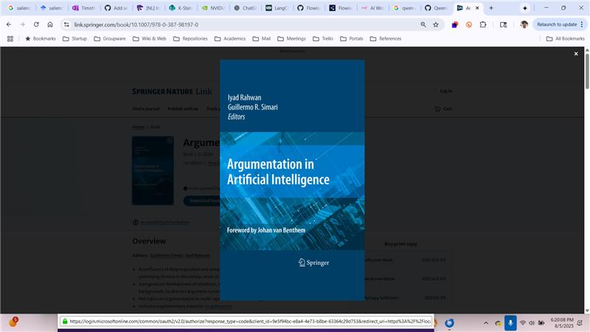
Argumentation in Artificial Intelligence | SpringerLink
Argumentation is all around us. Letters to the Editor often make points of cons- tency, and “Why” is one of the most frequent questions in language, asking for r- sons behind behaviour. And argumen...
link.springer.com
• EditedWilliam Hsu8/5/2025 4:20 PMhttps://link.springer.com/book/10.1007/978-0-387-98197-0 📷
https://eaglew.github.io

https://scholar.google.com/citations?view_op=view_citation&hl=en&user=HQcZOHMAAAAJ&cstart=20&pagesize=80&sortby=pubdate&citation_for_view=HQcZOHMAAAAJ:L8Ckcad2t8MC

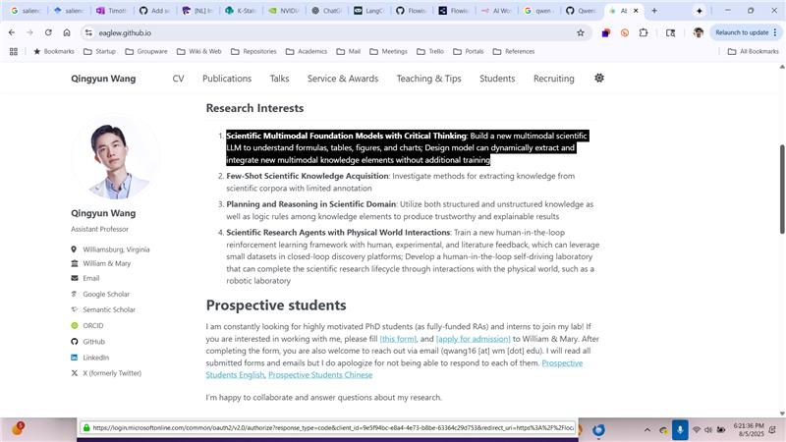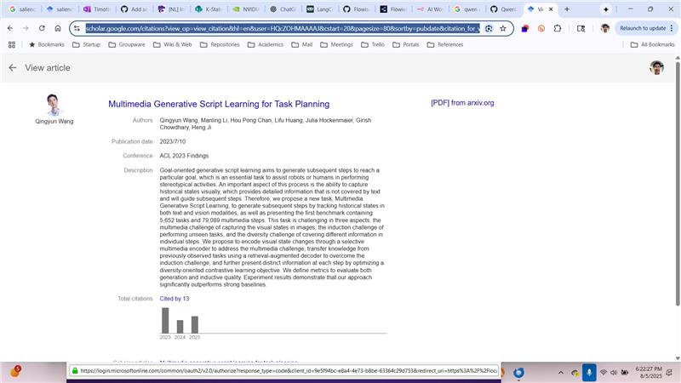
• EditedWilliam Hsu8/5/2025 4:22 PMhttps://eaglew.github.io https://scholar.google.com/citations?view_op=view_citation&hl=en&user=HQcZOHMAAAAJ&cstart=20&pagesize=80&sortby=pubdate&citation_for_view=HQcZOHMAAAAJ:L8Ckcad2t8MC 📷 📷
https://aclanthology.org/2023.findings-acl.63/
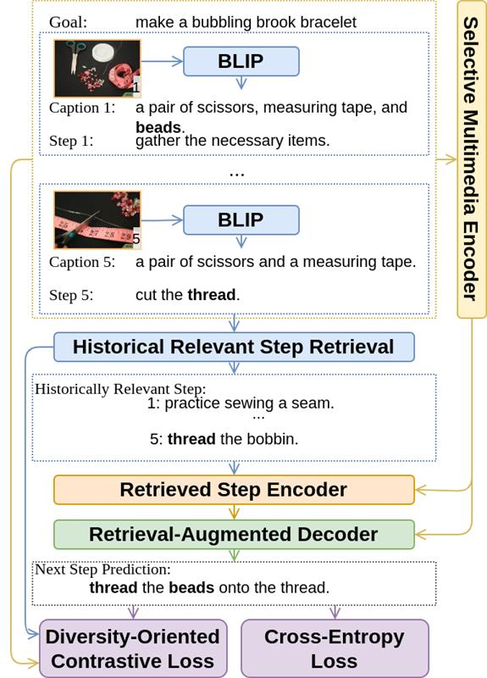
Qingyun Wang, Manling Li, Hou Pong Chan, Lifu Huang, Julia Hockenmaier, Girish Chowdhary, Heng Ji. Findings of the Association for Computational Linguistics: ACL 2023. 2023.
aclanthology.org
• William Hsu8/5/2025 4:26 PMhttps://aclanthology.org/2023.findings-acl.63/ 📷
Related open problems
- source attribution
- general commonsense reasoning
- agentic mixture-of-experts
• William Hsu8/5/2025 4:27 PMRelated open problems source attributiongeneral commonsense reasoningagentic mixture-of-experts
Aspects of trustworthiness
- source evaluation
- information fusion
- resolution of conflicting answers/viewpoints about textual entailment (interpretation) or evidential reasoning (citation)
• William Hsu8/5/2025 4:30 PMAspects of trustworthiness source evaluationinformation fusionresolution of conflicting answers/viewpoints about textual entailment (interpretation) or evidential reasoning (citation)
Underlies our approach to:
- GraphRAG (& GNNs)
- Verifiable reasoning
  - Modal
  - Constraint-based
  - Type-based
• William Hsu8/5/2025 4:31 PMUnderlies our approach to: GraphRAG (& GNNs)Verifiable reasoning ModalConstraint-basedType-based
Debate tasks: flagging misinfo & specious arguments?
• Edited
Patrick: dialogic approach vs. adversarial
- “yes, and”
- improvisational methods
• This message has been deleted.
• William Hsu8/5 4:47 PMImportantWilliam Hsu8/5/2025 4:39 PMPatrick: dialogic approach vs. adversarial “yes, and”improvisational methods
Bill to update
- tasking in GHP
- DC services for OIE including seed sources and retrieval apps/scripts
- proposed NL understanding use cases for IE in agentic reasoning systems
• Meeting ended: at 8/5 6:02 PM after 2 hours 55 minutes 39 seconds8/5 6:02 PM Meeting ended: 2h 55m 39s View recap
• Recording has stopped. Saving recording…8/5 6:02 PM Recording has stopped. Saving recording…
• Recording Recording2h 55m 35sContext menu availableRecordingWilliam HsuThis recording has an expiration date. Click here to view or change it. Learn moreTranscripthas context menu

has context menu

